

Graduation Project Proposal
<HimaTech>

Prepared by

<Badryah Aljabri, 445200939>
<Dana Alotaibi, 445203123>
<Aisha Alonizy, 445200424 >
<Maryam Almazyad, 445204412>

Supervised by
<Dr. Hala Alshamlan >

Table of Contents

1 Introduction 3
2 The Problem 3
3 The Solution 3
4 Product Vision 3
5 Product Roadmap 4
6 Objectives 4
7 Scope 4
8 Hardware/Software Tools and Cost 5
9 Scrum Team 6
9.1 Skill Set Requirements 6
9.2 Roles and Responsibilities 6
10 References 6

Introduction
AI-based digital protection systems play an increasingly important role in enhancing children's safety across digital communication and interactive online platforms. As children spend more time using social media, messaging applications, online games, and educational platforms, they become more vulnerable to digital threats, particularly cyberbullying and online grooming. However, many existing parental control systems rely on keyword filtering or manual monitoring, making it difficult to understand conversation context and recognize gradually developing harmful interactions.
This project proposes the development of HimaTech, an AI-powered child digital protection system consisting of a smart keyboard for the child’s device and a parental monitoring application. The system uses Artificial Intelligence (AI) and Natural Language Processing (NLP) to analyze Arabic text contextually, recognize relevant behavioral patterns, detect potential cyberbullying and online grooming risks, generate an age-adaptive Dynamic Risk Score, and notify parents through smart alerts while preserving the child’s privacy.
The importance of this technological solution lies in providing a more intelligent and proactive approach to child digital protection compared to traditional parental control systems. Locally, the system aims to help families in Saudi Arabia improve children’s online safety and support earlier identification of potentially harmful digital interactions. More broadly, the project demonstrates how contextual AI and behavioral analysis can be applied to support child protection while considering digital privacy.
This document presents the project background, defines the child digital protection problem, describes the proposed solution, and outlines the product vision, development roadmap, objectives, scope, required tools, and project team.

The Problem
With the rapid growth of children’s use of digital platforms, social media, messaging applications, online games, and educational platforms, they are becoming increasingly exposed to digital threats, particularly cyberbullying and online grooming. Children interact with these platforms daily without fully understanding the risks present in digital environments, making them more vulnerable to harmful and manipulative online interactions.
Cyberbullying may involve repeated harassment, insults, threats, or other harmful communication, while online grooming may develop gradually through seemingly normal interactions before progressing into manipulative or risky behavior. As a result, identifying these threats during their early stages can be challenging when individual messages are considered without their broader interaction context.
Many existing parental control systems rely on keyword filtering or manual parental monitoring. While these approaches may identify explicit harmful content, they may be limited in understanding the context of text and recognizing behavioral patterns that develop over time. Consequently, some indirect or gradually developing risks may not be identified effectively through static keyword-based approaches alone.
Therefore, there is a need for an intelligent digital protection system capable of analyzing Arabic text contextually, recognizing relevant behavioral patterns, and identifying indicators of cyberbullying and online grooming while preserving children’s privacy.

The Solution
This project proposes the development of HimaTech, an intelligent AI-powered child digital protection system that acts as a proactive protection layer within the child’s digital environment. The system consists of an AI-powered keyboard on the child’s Android device and a parental monitoring application, allowing parents to configure protection settings and receive smart risk alerts.
The HimaTech keyboard analyzes text entered through the child’s keyboard using Artificial Intelligence (AI) and Natural Language Processing (NLP). Instead of relying solely on static keyword filtering, the system applies contextual and behavioral analysis to identify indicators associated with cyberbullying and online grooming.
To support contextual analysis while maintaining privacy, the system processes the current text through a temporary message buffer and maintains a limited rolling context when needed for analysis. Relevant behavioral indicators are represented through a behavioral state, allowing the system to consider patterns that develop over time without permanently storing full conversations.
The text is analyzed using a fine-tuned MARBERTv2 model to obtain a contextual representation of the Arabic text. This information is combined with relevant behavioral features to support risk classification. The system also generates an age-adaptive Dynamic Risk Score based on the child’s age group configured by the parent and the detected interaction risk.
When the detected risk exceeds a predefined threshold, the system provides the parent with a smart alert and summarized risk information through the parental application. Full conversations are not permanently stored or exposed to the parent, helping maintain a balance between child safety and digital privacy.
By combining contextual Arabic text analysis, behavioral pattern recognition, age-adaptive risk assessment, and privacy-preserving temporary processing, HimaTech aims to support earlier identification of cyberbullying and online grooming risks and enable parents to respond to potentially harmful situations more effectively.

Product Vision

Product Vision:
For a Parents of children in Saudi Arabia
Who need a smarter way to protect their children from online threats
The HimaTech is a AI-powered child digital protection application
That Detects cyberbullying and online grooming through contextual and behavioral analysis and provides timely risk alerts to parents unlike Google Family Link and Qustodio
our product uses contextual AI and age-adaptive risk assessment for proactive child protection.

Product Roadmap
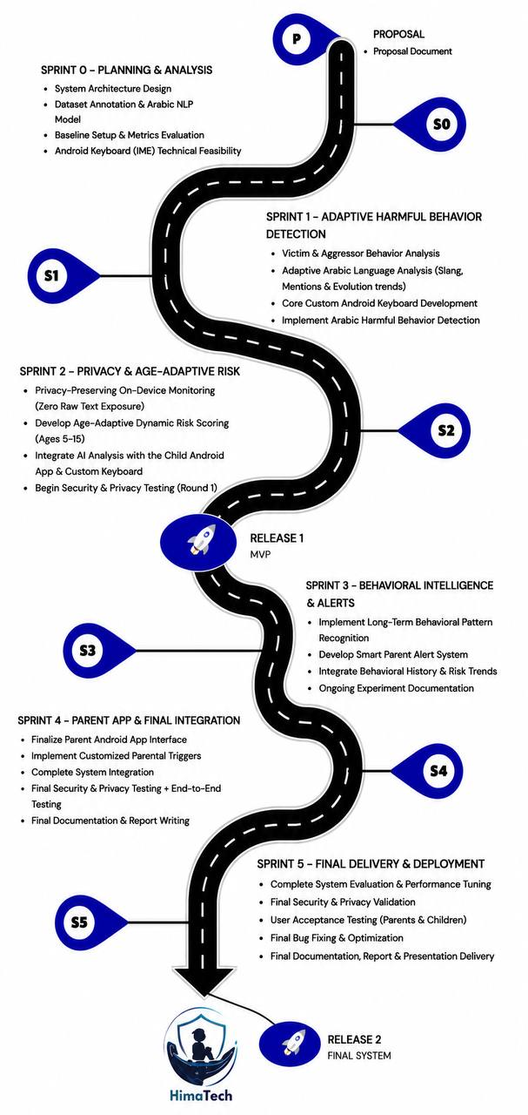

Objectives
Describe the objectives of the graduation project on three levels: product, project, and learning. Think of these objectives as achievements you would add to your CV after completing the project.
- Product (customer focus-value):

- Provide an AI-powered keyboard application to analyze children’s Arabic digital interactions and identify potential online risks.
- Enable the system to detect cyberbullying and online grooming using AI-based contextual and behavioral analysis.
- Enable the system to analyze text contextually to identify potentially harmful interaction patterns.
- Provide age-adaptive Dynamic Risk Scores based on the child’s age and detected interaction risks.
- Provide parents with smart alerts when the detected risk exceeds a predefined threshold.
- Enable parents to monitor identified risks through a parental application without exposing full conversations.
- Preserve children’s privacy by processing conversation content temporarily without permanently storing full conversations

- Project (solution focus-plan):

- Analyze user and system requirements for the child protection and parental monitoring system.
- Collect, preprocess, label, and prepare Arabic NLP datasets for AI model training and evaluation.
- Design the architecture of the AI-powered keyboard, temporary text processing, contextual analysis, behavioral analysis, risk assessment, and parental monitoring components.
- Fine-tune and evaluate MARBERTv2 for Arabic cyberbullying and online grooming detection.
- Develop and integrate behavioral analysis and age-adaptive Dynamic Risk Scoring with the AI classification model.
- Develop and integrate the child keyboard application and parental dashboard.
- Implement a privacy-preserving temporary processing mechanism that analyzes conversation content without permanently storing full conversations.
- Test and evaluate the complete system to ensure classification performance, functionality, usability, and reliability.
- Deploy the final system and prepare technical and user documentation.

- Learning (student focus):

- Apply Natural Language Processing techniques for contextual analysis of Arabic digital conversations.
- Fine-tune and evaluate pre-trained AI models for contextual text classification.
- Apply behavioral analysis and risk-scoring techniques to identify potentially harmful digital interactions.
- Develop and integrate an AI-powered Android keyboard and parental monitoring application.
- Apply privacy-preserving principles when designing AI systems for children.
- Integrate AI models into real-world mobile applications.

Scope
This project focuses on developing an AI-powered child digital protection application that uses Artificial Intelligence (AI) and Natural Language Processing (NLP) to analyze Arabic text entered through the child’s keyboard and identify potential cyberbullying and online grooming risks.
The scope of this project includes:

- Developing the application for the Android platform only.
- Supporting the Arabic language only.
- Analyzing text-based conversations using AI and NLP techniques.
- Detecting cyberbullying and online grooming using contextual and behavioral text analysis.
- Generating an age-adaptive Dynamic Risk Score based on the child's age configured by the parent.
- Sending intelligent alerts to parents while preserving children's privacy without exposing full conversation details.
- Temporarily processing conversation content without permanently storing full conversations.

The project does not include:

- Support for iOS devices.
- Support for languages other than Arabic.
- Analysis of images, videos, or voice messages.
- Storage or sharing of complete conversations with parents.
- Integration with external devices or third-party platforms.
- monitoring incoming text from the other party, as the system operates exclusively on the user's input.

Hardware/Software Tools and Cost

Hardware Tools
Name and Description | Cost  mention date it will be available
Android Smartphone (Testing Device) –Used to test the parent and child applications. | Available
Laptop/PC – Used for application development, AI model training, and testing. | Available
Software Tools
Name and Description | Cost
Android Studio – IDE for Android application development. | Free
Flutter SDK – Cross-platform mobile development framework | Free
Hugging Face Transformers – Used to load, fine-tune, and evaluate MARBERTv2. | Free
Visual Studio Code – Code editor for AI and backend development | Free
Firebase Authentication – User authentication and device management. | Free
Firebase Cloud Messaging (FCM) – Smart push notifications to parents. | Free
GitHub – Version control and collaboration. | Free
MARBERTv2 (Pre-trained AI Model) – Arabic language model used as the main AI model for contextual analysis of Arabic conversations and fine-tuned to detect cyberbullying and grooming. | Free

Scrum Team

Skill Set Requirements

Technical Skill Required | What is the current level of the team (beginner-intermediate- advanced) for each skill? How will the gap be bridged? (if necessary) Learning plan
Python Programming | Intermediate
Machine Learning | Beginner–Intermediate
Natural Language Processing (NLP) | Beginner (Follow NLP tutorials and implement preprocessing, tokenization, text classification, and contextual analysis.)
Dataset Preparation & Data Labeling | Intermediate
Deep Learning | Beginner (Study neural networks and transformer architectures through practical tutorials and implement a basic text classification model.)
Cybersecurity | Beginner–Intermediate
Model Evaluation | Beginner (Learn evaluation metrics such as Precision, Recall, F1-score, and Confusion Matrix and apply them to the trained models.)
Backend Development & APIs | Intermediate

Roles and Responsibilities
Scrum Team
Product Owner:  (list name of the project supervisor) | Dr. Hala Alshamlan
Developers: (list student names) | Badryah Aljabri  Dana Alotaibi  Aisha Alonizy  Maryam Almazyad
Scrum Master (SM):  (list name of designated SM for the project) | Badryah Aljabri
Stakeholders:  (list names of project stakeholders, include customer names if any) | Dr. Hala Alshamlan, Parents, Children, Project Team.

References

[1] UNICEF UK, “Online Violence – Keeping Children Safe Online,” UNICEF UK.

[2] Google, “Family Link – Family Safety & Parental Control Tools,” Google Families.

[3] Qustodio, “Parental Control and Digital Wellbeing Features,” Qustodio.

